

VIT BHOPAL UNIVERSITY
School of Computing Science and Engineering
Bhopal-Indore Highway, Kothrikalan, Sehore
Madhya Pradesh - 466114

CSA3006 DATA MINING AND DATA WAREHOUSING

REG.NO : 23BAI10307
NAME : Janvie Verma
BRANCH : CSE(AI & ML)
SEMESTER: Winter Semester 2025-26

INDEX

Ex.NO | DATE | EXPERIMENT NAME | PAGE NO.
1 | 09.01.25 | Exploring WEKA and Building an anonymous Data Warehouse
2 |  | Implementation of several data pre-processing tasks on datasets.
3 |  | Implementation of association rule mining on data sets
4 |  | Implementation of classification techniques: Naïve Baye’s, and SVM on data sets
5 |  | Implementation of regression techniques: linear, logistics and Neural Networks on data sets
6 |  | Implementation of k-means and graph-based clustering techniques on data sets
7 |  | Credit Risk Assessment. Sample Programs using German Credit Data
8 |  | Sample Programs using Hospital Management System
9 |  | Beyond the Syllabus -Simple Project on Data Pre-processing

EXP.NO: 01 | Exploring WEKA and Building an anonymous Data Warehouse
DATE: 09.01.25 | Exploring WEKA and Building an anonymous Data Warehouse

AIM

To implement Decision Tree learning using WEKA and generate a decision tree model for classification.

PROCEDURE

- Open WEKA and click on Explorer.
- Click Open file and load the dataset (.csv or .arff).
- Go to the Preprocess tab and check the attributes.
- Remove unwanted or sensitive attributes if needed.
- Go to the Classify tab.
- Click on Choose → trees → J48 (Decision Tree algorithm).
- Select the class attribute (target variable).
- Click on Start to run the classifier.
- Observe the generated:
- Decision tree
- Accuracy
- Confusion matrix
Save the model if required.

INPUT

A dataset containing attributes and class labels.
Input (anonymous_student_data.arff):
- Age
- Gender
- Department
- CGPA
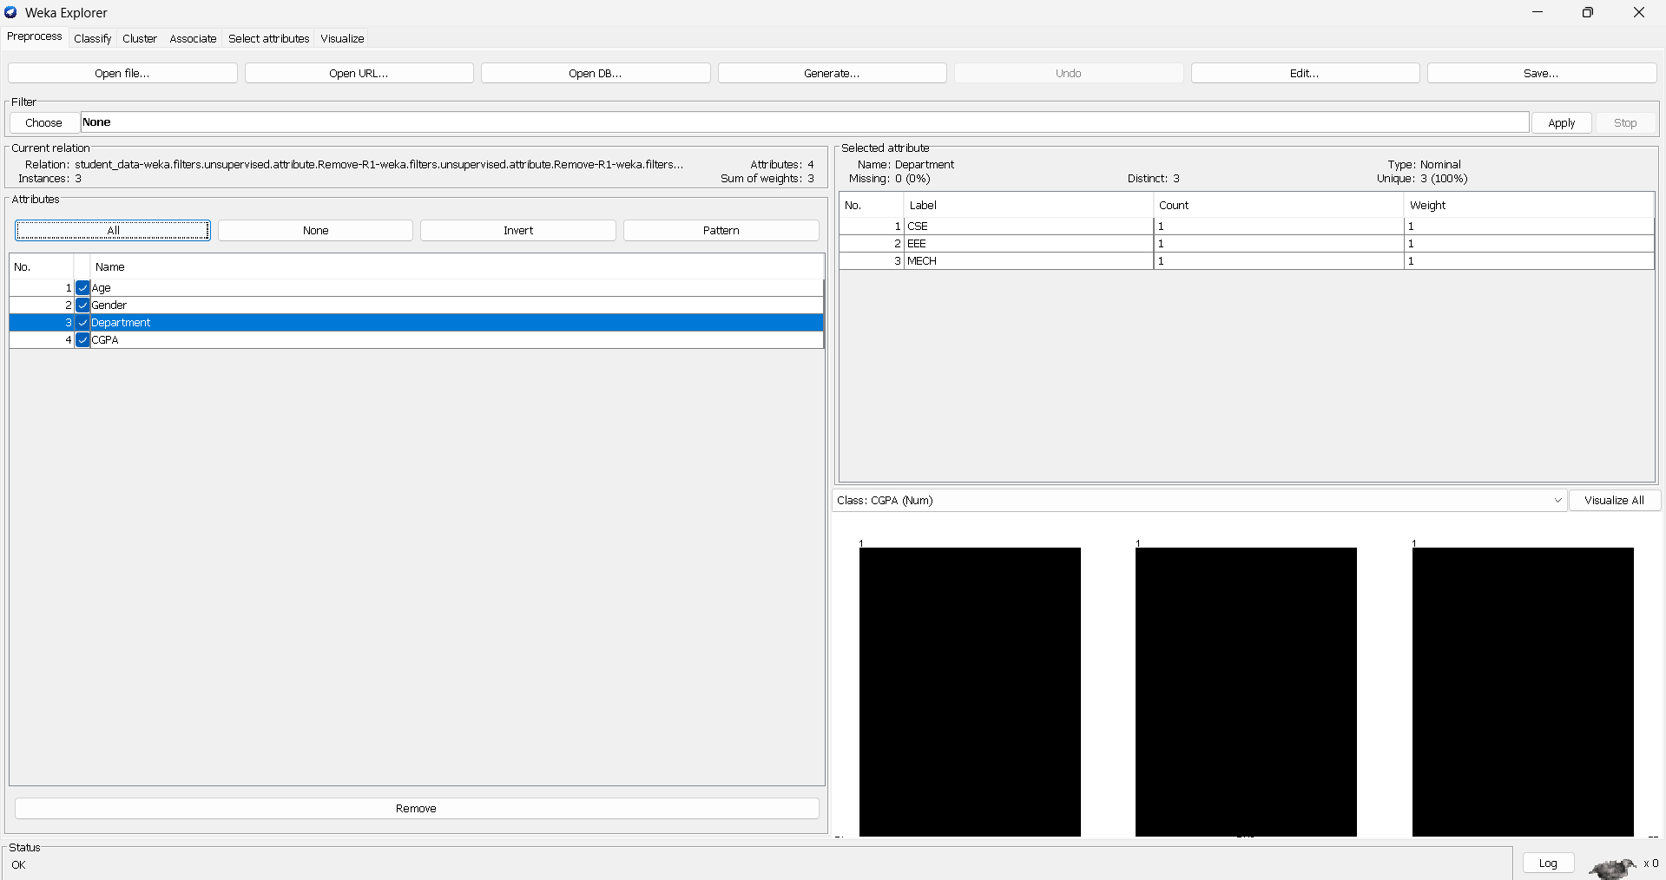

OUTPUT

- A generated Decision Tree model
- Classification accuracy
- Confusion matrix
- Correctly and incorrectly classified instances
(WEKA displays all these after clicking Start)

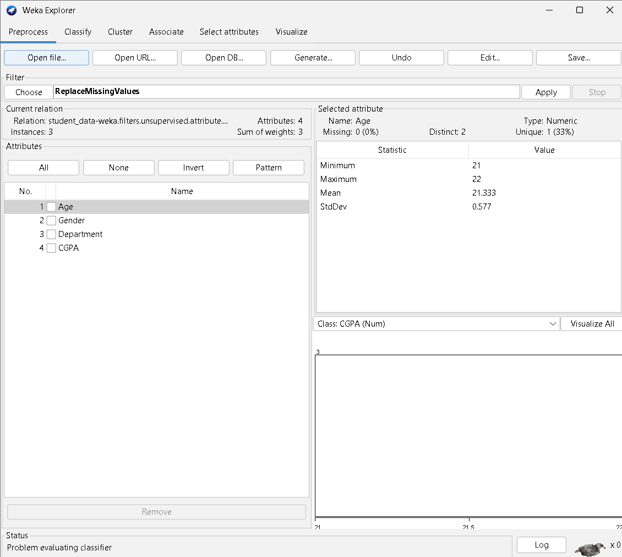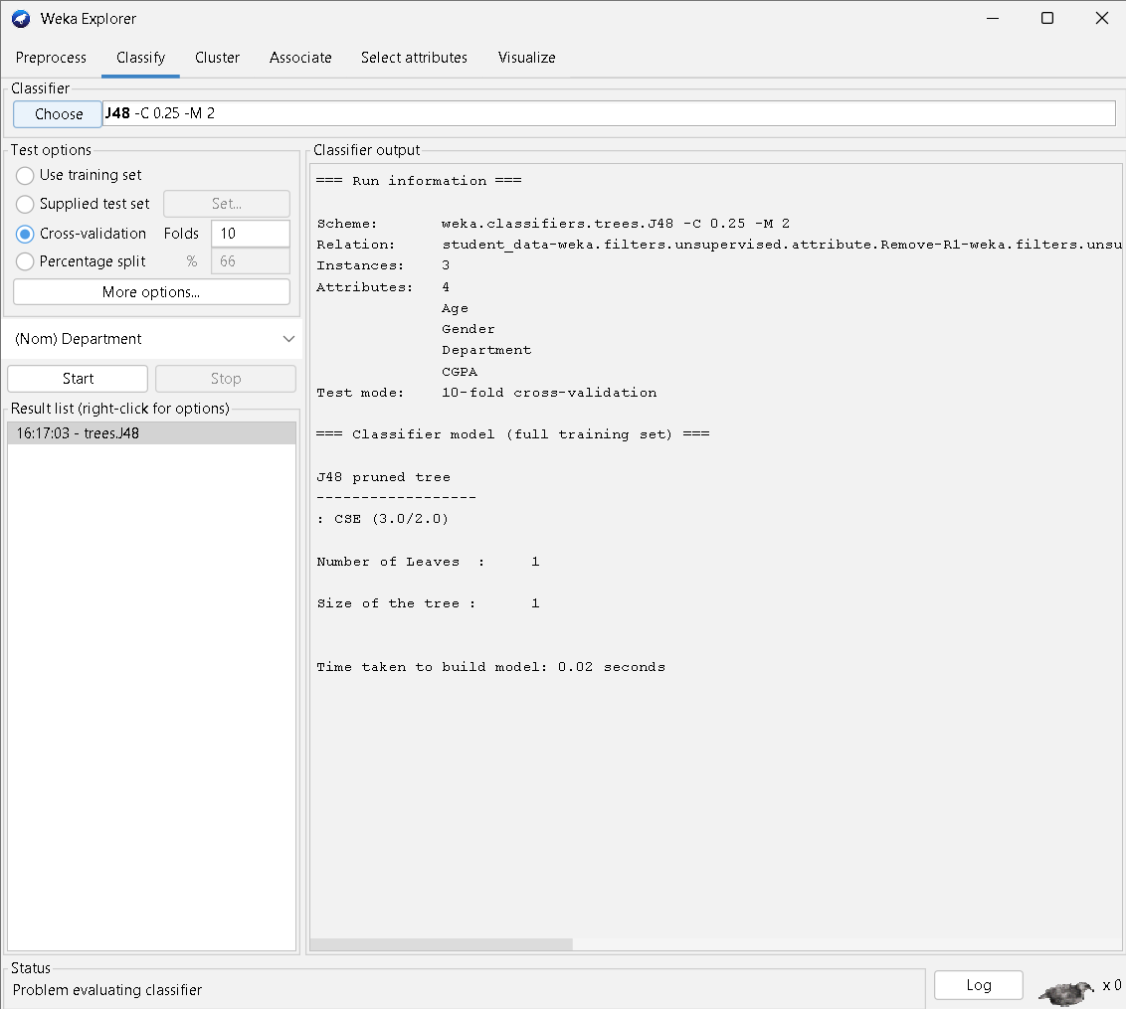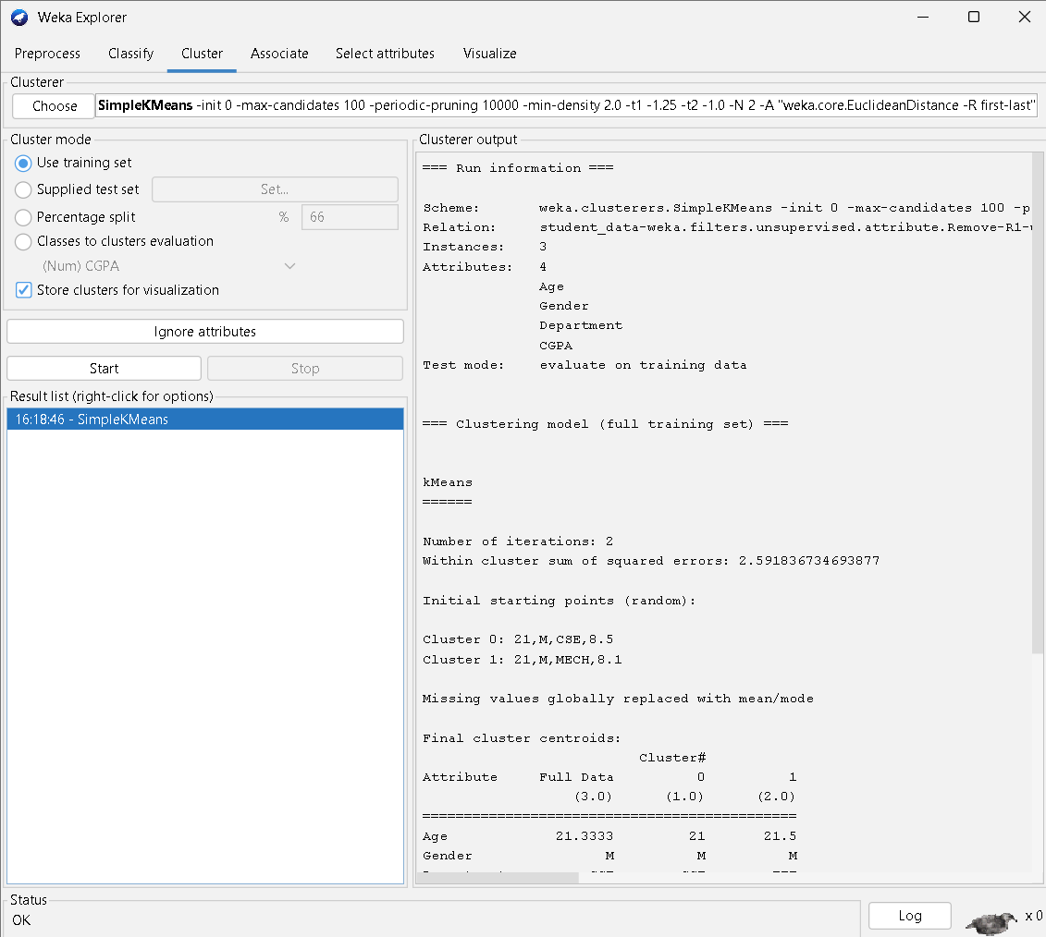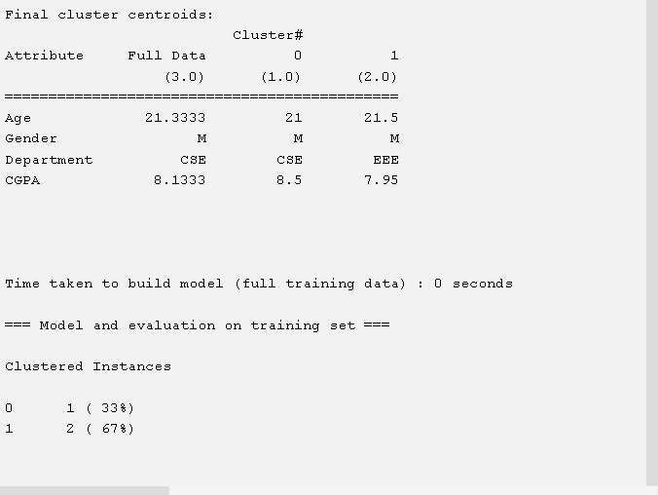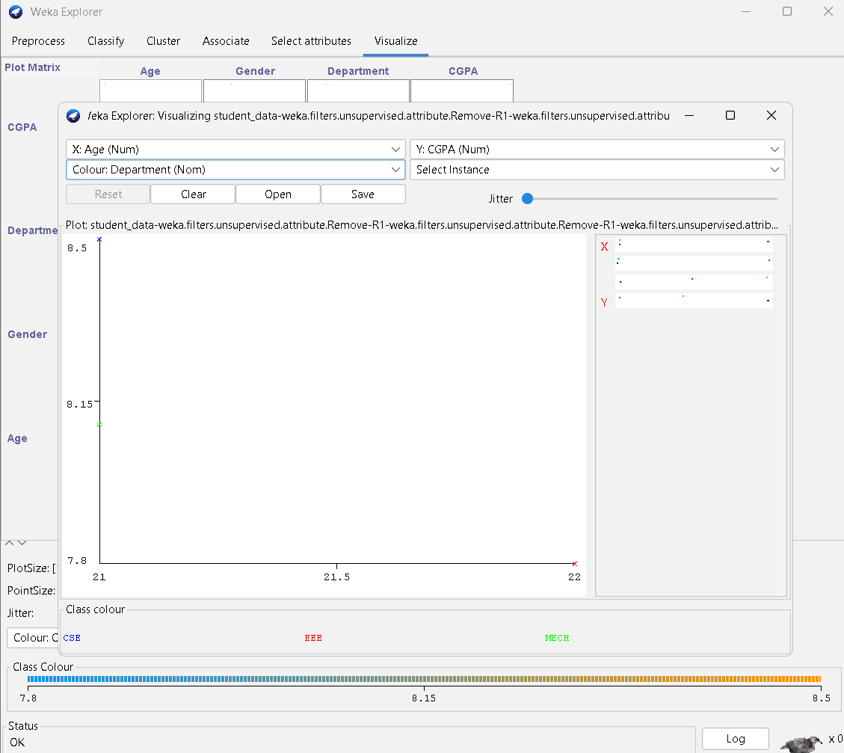

RESULT

Thus, the Decision Tree learning algorithm (J48) was successfully implemented using WEKA and a classification model was generated from the given dataset.

EXP.NO: 02 | Implementation of several data pre-processing tasks on datasets.
DATE:

AIM

To perform data pre-processing on a given dataset using the WEKA tool, including missing value handling, normalization, discretization, attribute selection, and attribute removal.

PROCEDURE

- Opened the WEKA application and selected Explorer mode.

- Loaded the given dataset using the Open file option in the Preprocess tab.
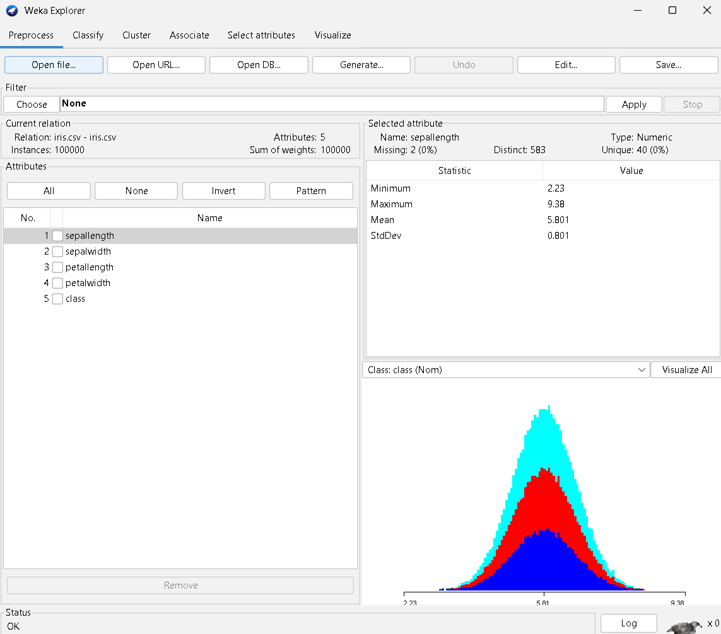

- Performed missing value handling using the ReplaceMissingValues filter.
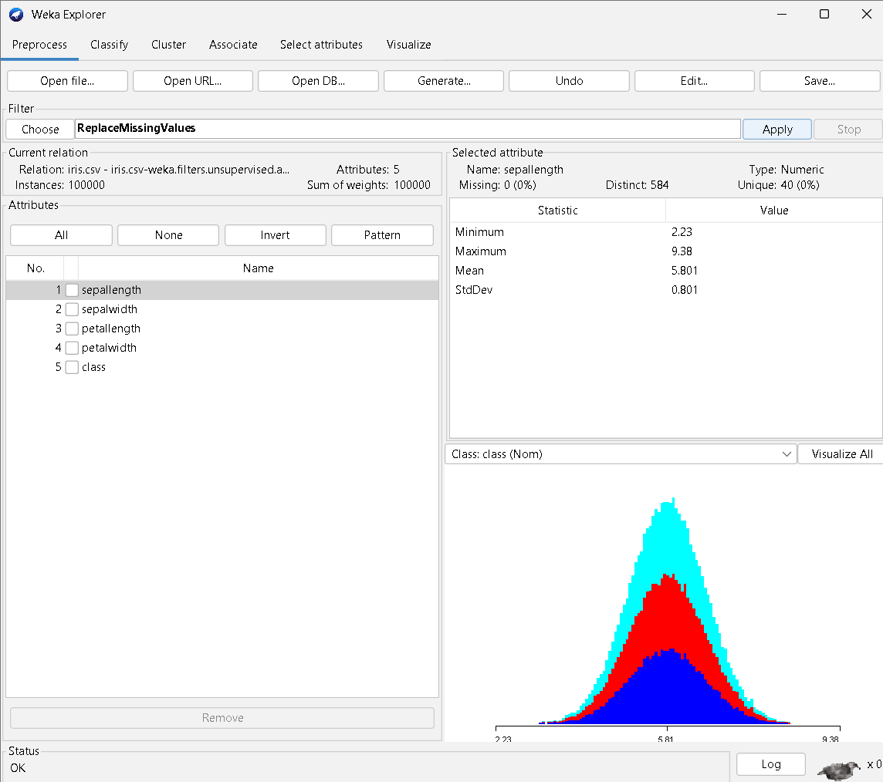

- Applied normalization to scale numeric attributes using the Normalize filter.
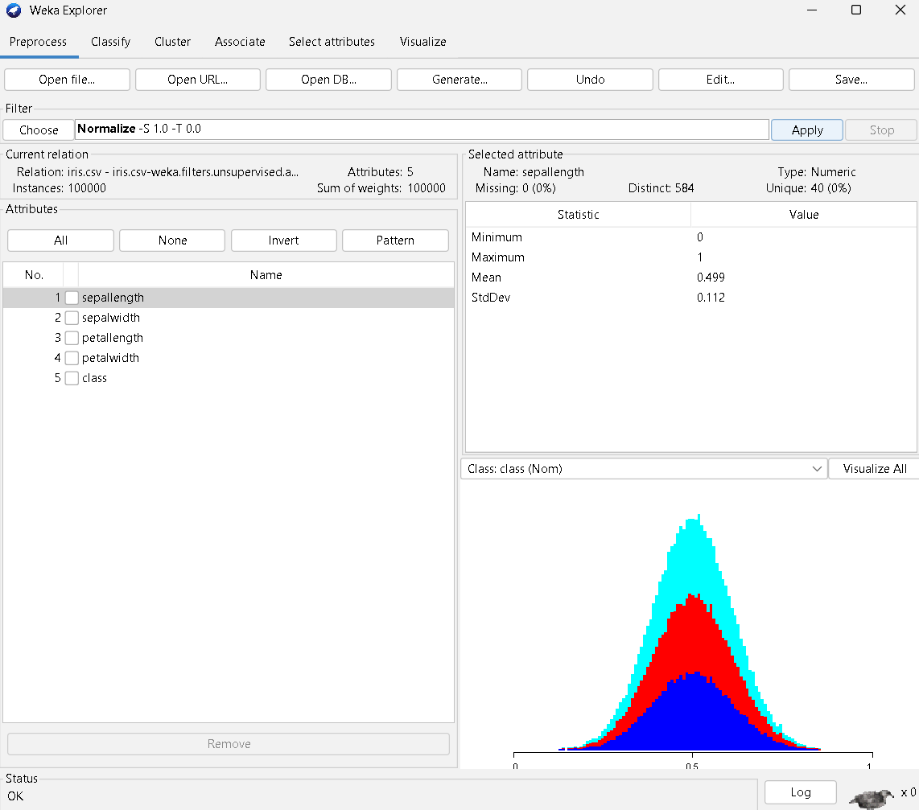

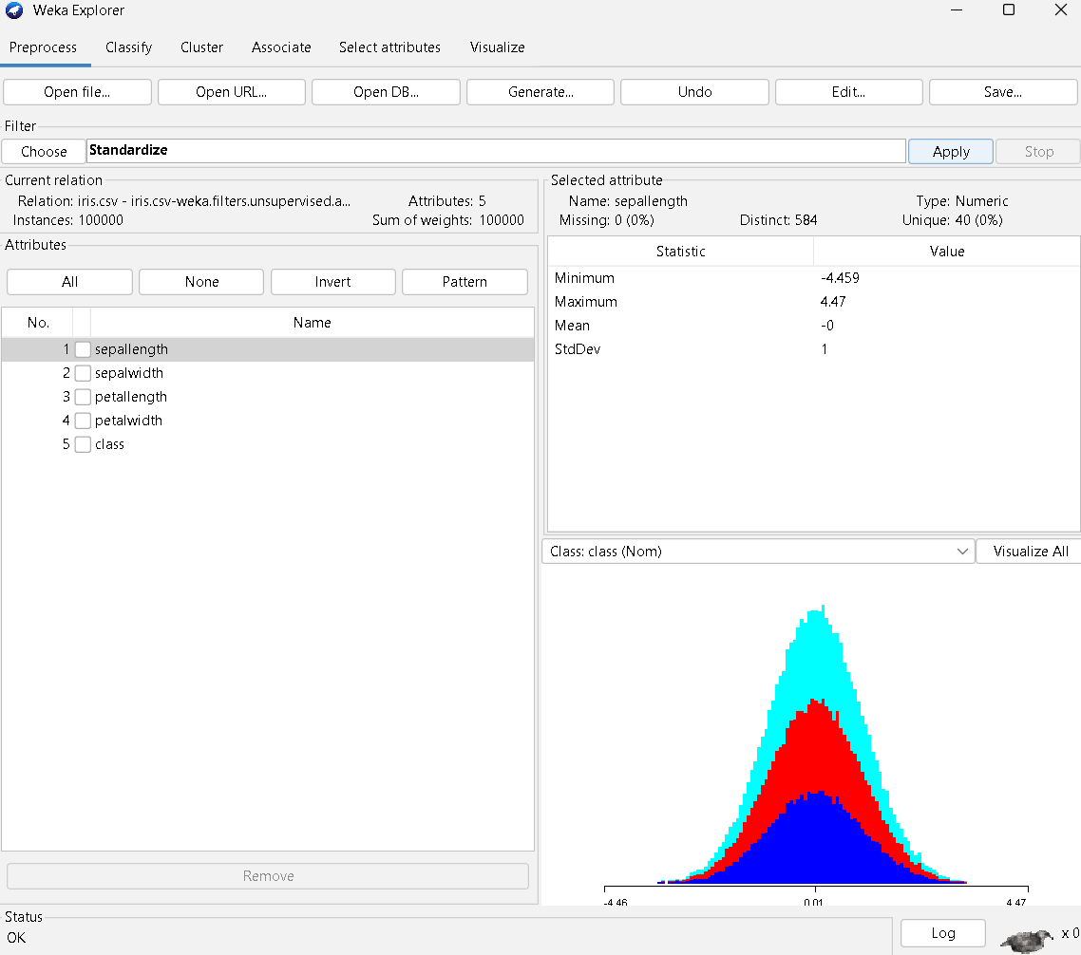

- Converted numeric attributes into categorical values using the Discretize filter.
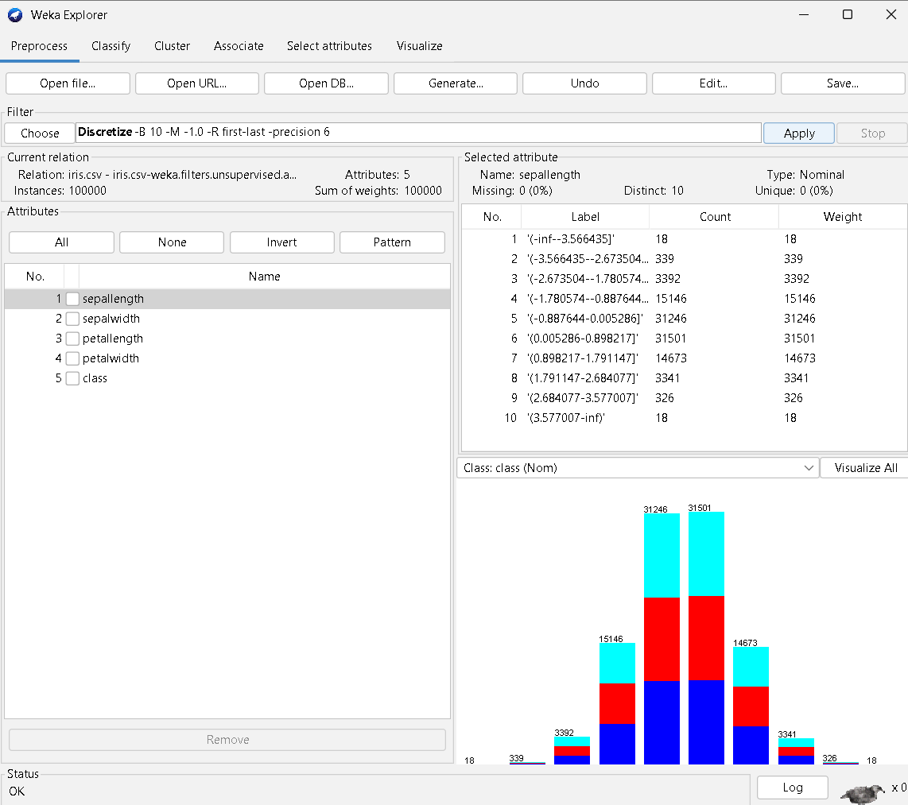

- Selected relevant attributes using the Select Attributes tab with suitable evaluators.
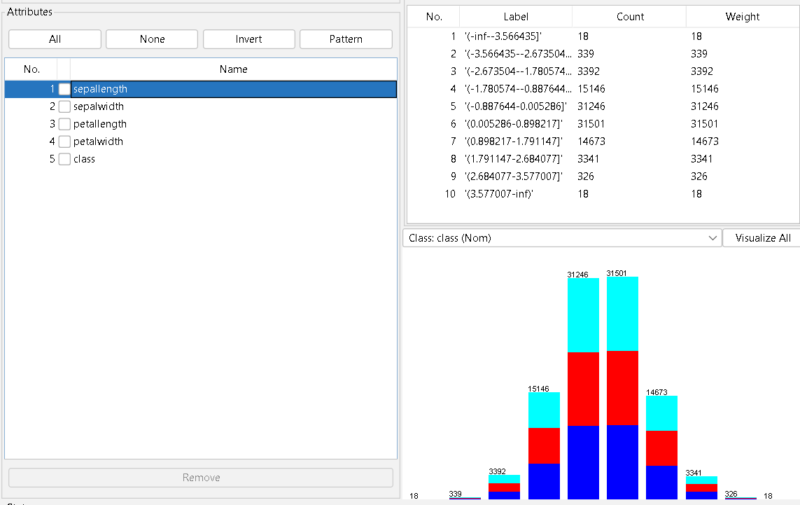
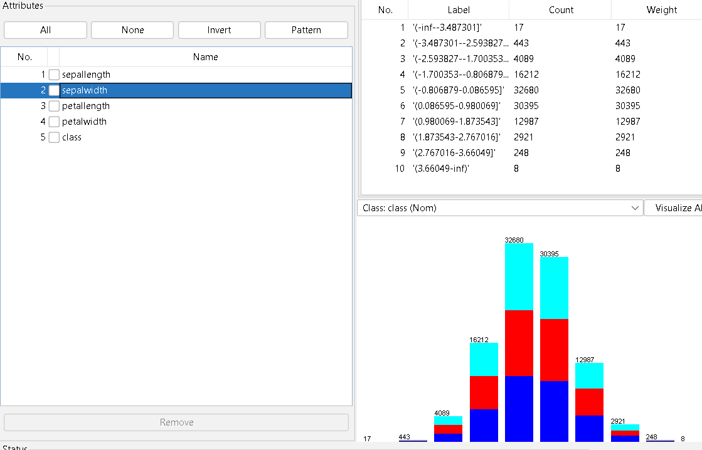
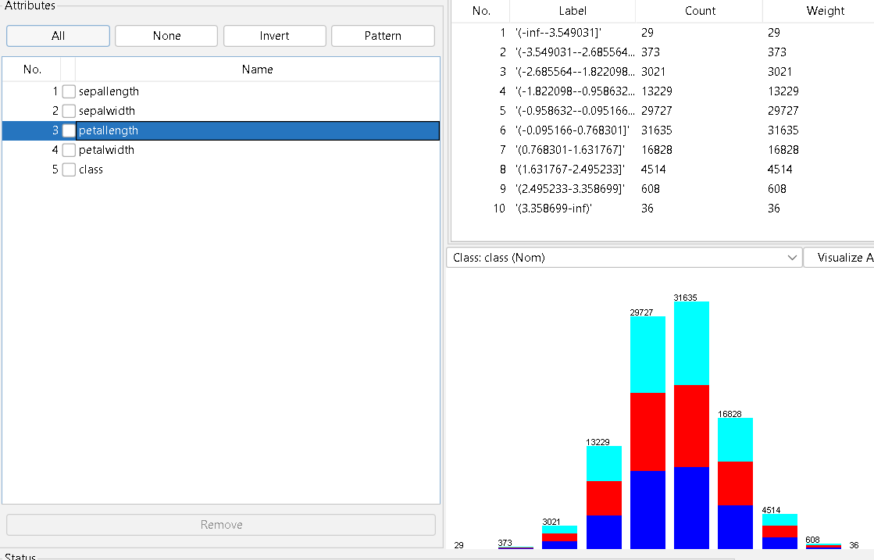
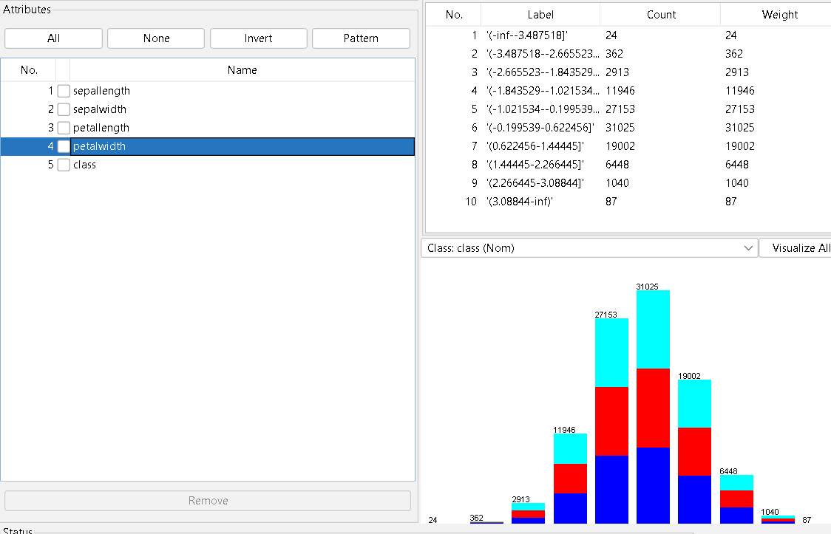
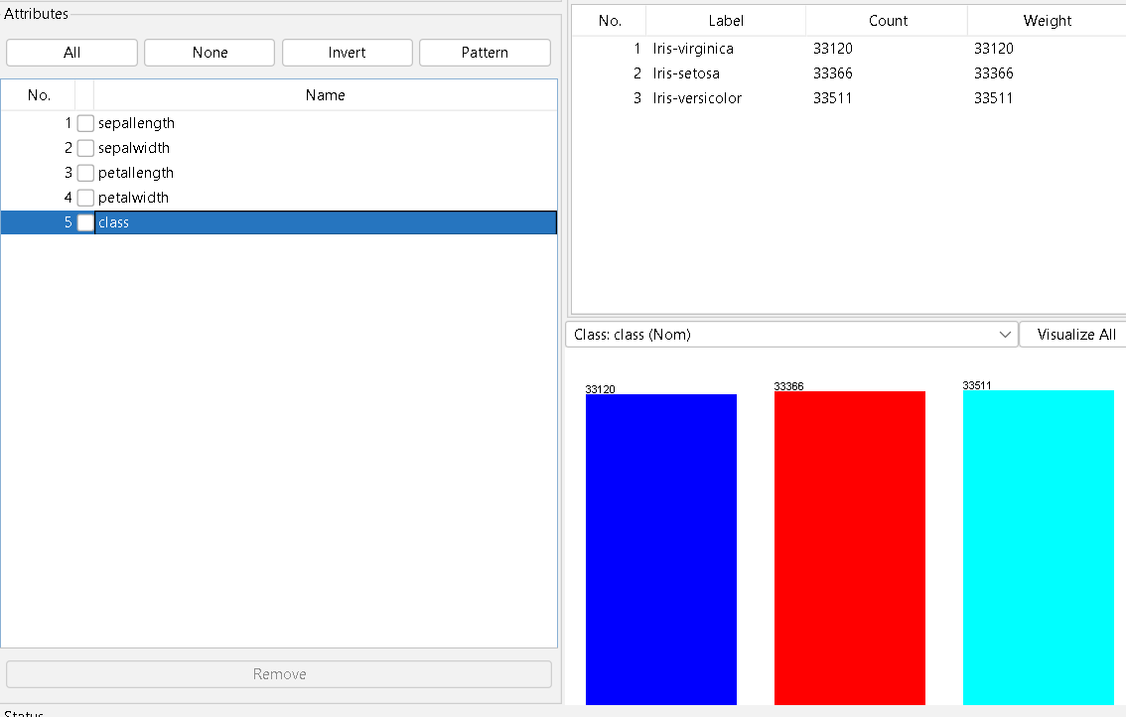
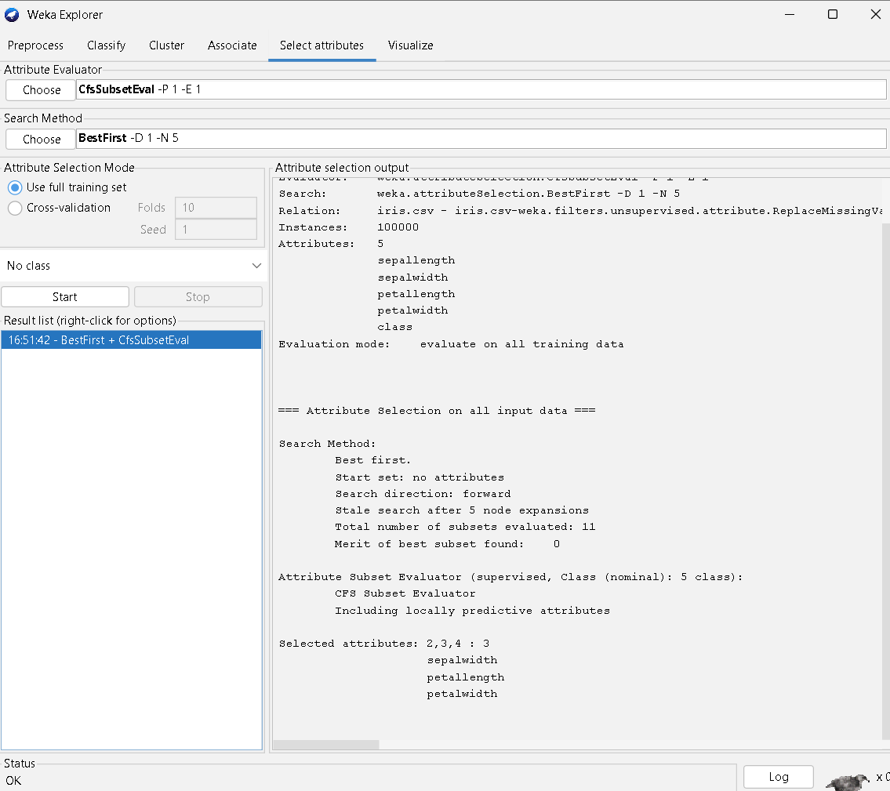

- Removed unwanted attributes using the Remove filter.
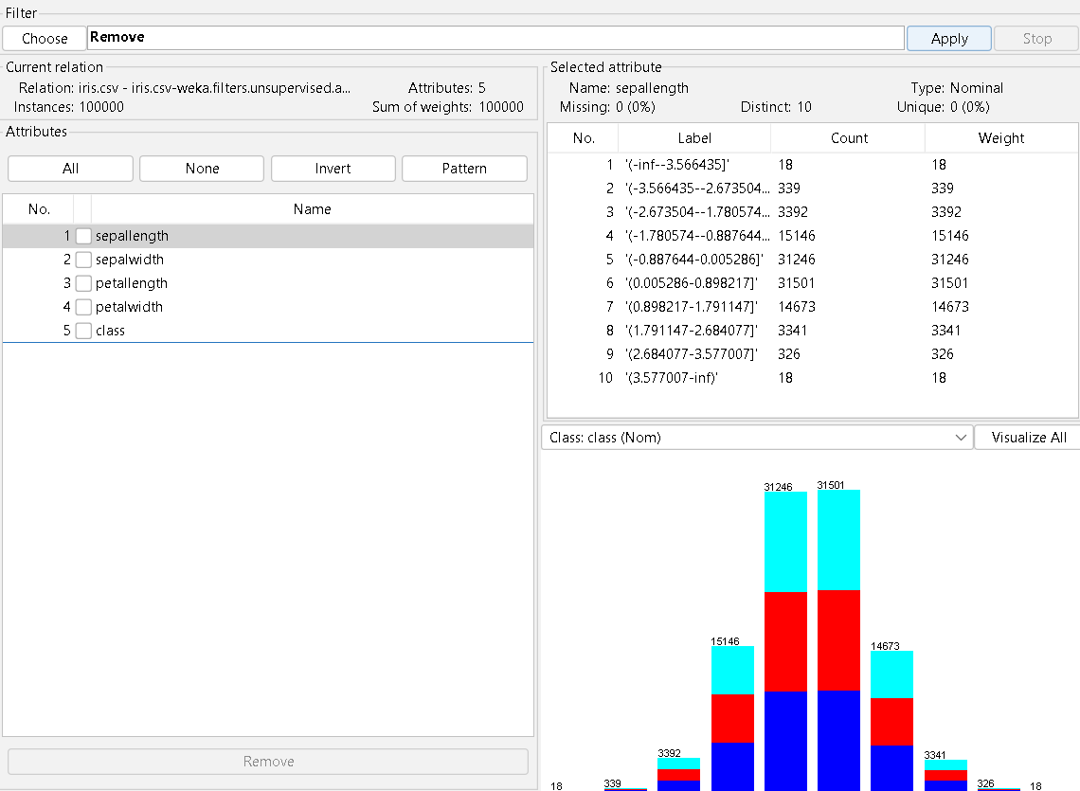

- Observed the changes after each step and captured screenshots.

INPUT

The input is a dataset in CSV format containing multiple attributes with missing values, numeric values, and irrelevant attributes.
iris.csv

OUTPUT

The output is a pre-processed dataset in which:
- Missing values are handled
- Data is normalized
- Numeric attributes are discretized
- Important attributes are selected
- Unnecessary attributes are removed
The cleaned dataset is suitable for further data mining tasks.
iris.arff(preprocessed)

RESULT

Thus, data pre-processing tasks such as missing value handling, normalization, discretization, attribute selection, and attribute removal were successfully performed using the WEKA tool, resulting in a clean and well-structured dataset.

EXP.NO: 03 | Implementation of association rule mining on data sets
DATE: 06.02.25 | Implementation of association rule mining on data sets

AIM
Implementation of association rule mining on data sets.
PROCEDURE
✞ Collect the transactional dataset containing items such as Milk, Bread, Butter, etc.
✞ Open the dataset in Excel and remove unnecessary empty columns. ✞ Replace all missing values (NaN) with No.
✞ Ensure that all attributes contain only Yes/No values.
✞ Save the cleaned file in CSV format (e.g., market_cleaned.csv). ✞ Open WEKA GUI Chooser.
✞ Click on Explorer.
✞ Go to the Preprocess tab.
✞ Click Open File and load the cleaned dataset.
✞ If required, convert attributes to nominal using: o Filter → Unsupervised → Attribute → NumericToNominal ✞ Click Apply to activate the filter.
✞ Go to the Associate tab.
✞ Click Choose and select Apriori algorithm.
✞ Click on the Apriori name to set parameters.
✞ Set:
o Minimum Support = 0.2 o Minimum
Confidence = 0.6 o Number of Rules = 10 ✞ Click OK.
✞ Click Start to run the algorithm.
✞ Observe the generated association rules in the output window. ✞ Note down support, confidence, lift, leverage, and conviction values. ✞ Analyze the strongest rules based on these measures.

INPUT
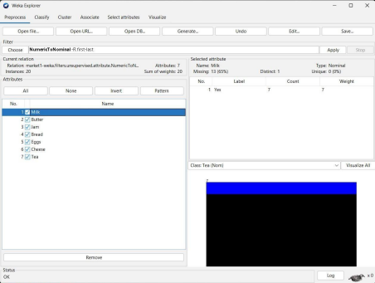
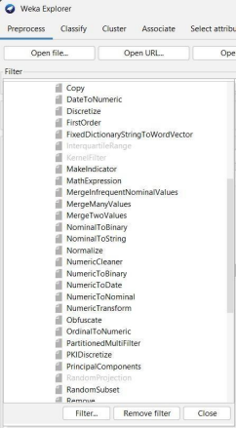

OUTPUT

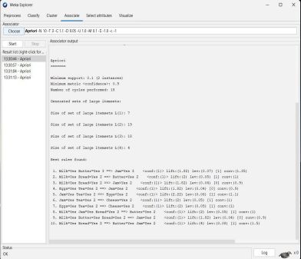
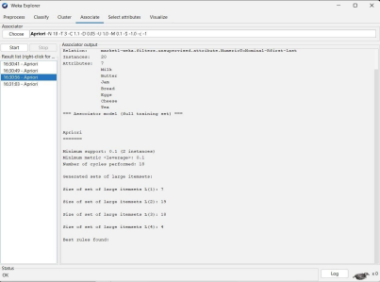
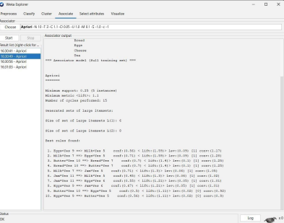
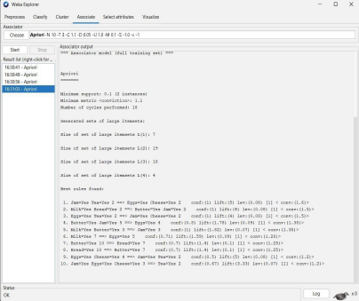
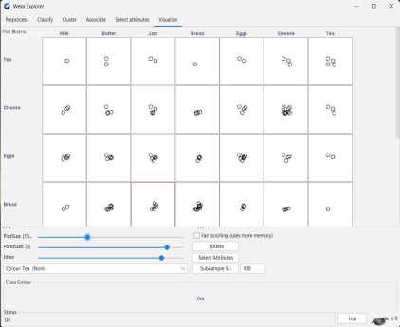

RESULT

After applying the Apriori algorithm on the transactional dataset using WEKA, several association rules were generated.
The discovered rules show relationships among different products such as Milk, Bread, Butter, Cheese, etc.

• The Apriori algorithm successfully generated frequent itemsets. • Several strong association rules were obtained.
• Items like Milk, Bread, Butter, and Cheese showed strong relationships. • Rules with high support, confidence, and lift were considered important.
• The results help understand customer purchasing behavior.
• These rules can be used for product placement and marketing strategies.

EXP.NO: 04 | Implementation of classification techniques: Naïve Baye’s, and SVM on data sets
DATE:

AIM

To implement and analyse Naïve Bayes and Support Vector Machine (SVM) classification techniques on a given dataset using WEKA.

PROCEDURE
- Open WEKA GUI Chooser.
- Click on Explorer.
- Go to the Preprocess tab.
- Click Open file and load the dataset (e.g., breast-cancer.arff).
- Verify that the class attribute is correctly selected (usually the last attribute).
- Switch to the Classify tab.

For Naïve Bayes:
- Click Choose → classifiers → bayes → NaiveBayes.
- Select 10-fold cross validation under Test options.
- Click Start.

For SVM:
- Click Choose → classifiers → functions → SMO.
- (Optional) Select kernel type (Polynomial / RBF).
- Choose 10-fold cross validation.
- Click Start.

INPUT
- Dataset: breast-cancer.arff
- Number of attributes: Depends on dataset
- Class attribute: Diagnosis / Class label
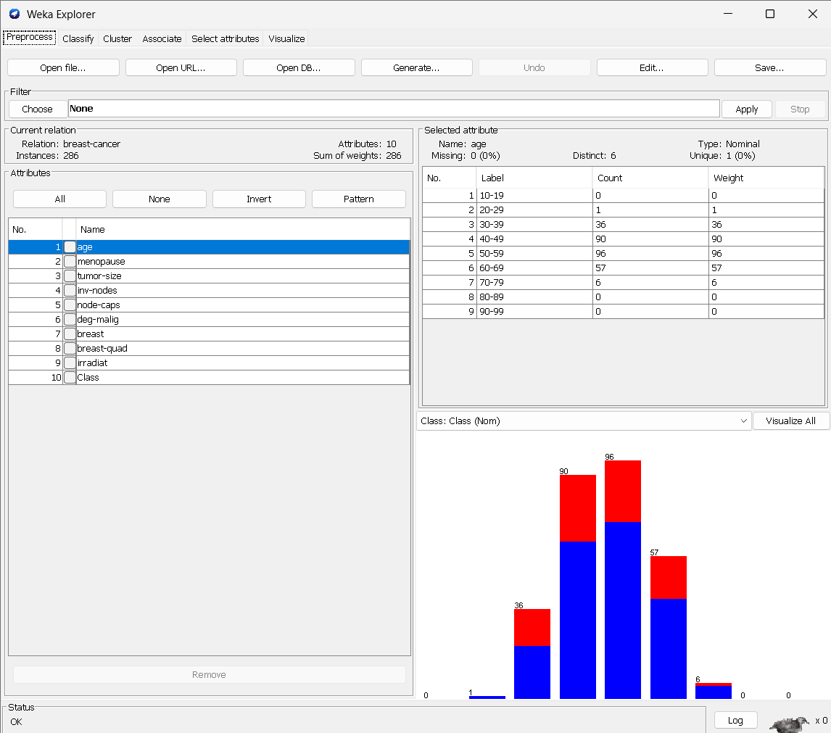

- Classification algorithms:

  - Naïve Bayes
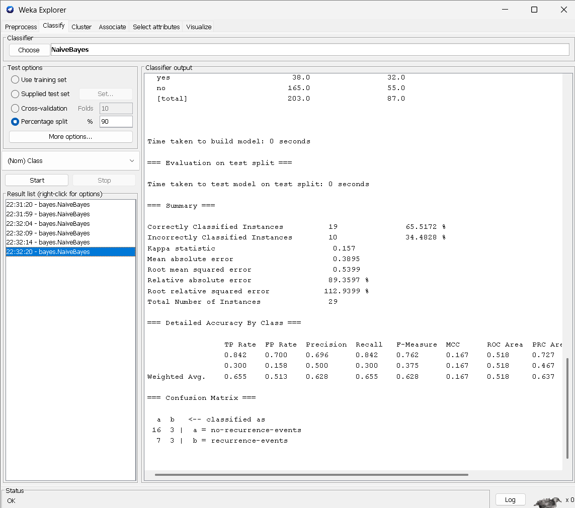

  - Support Vector Machine (SMO)
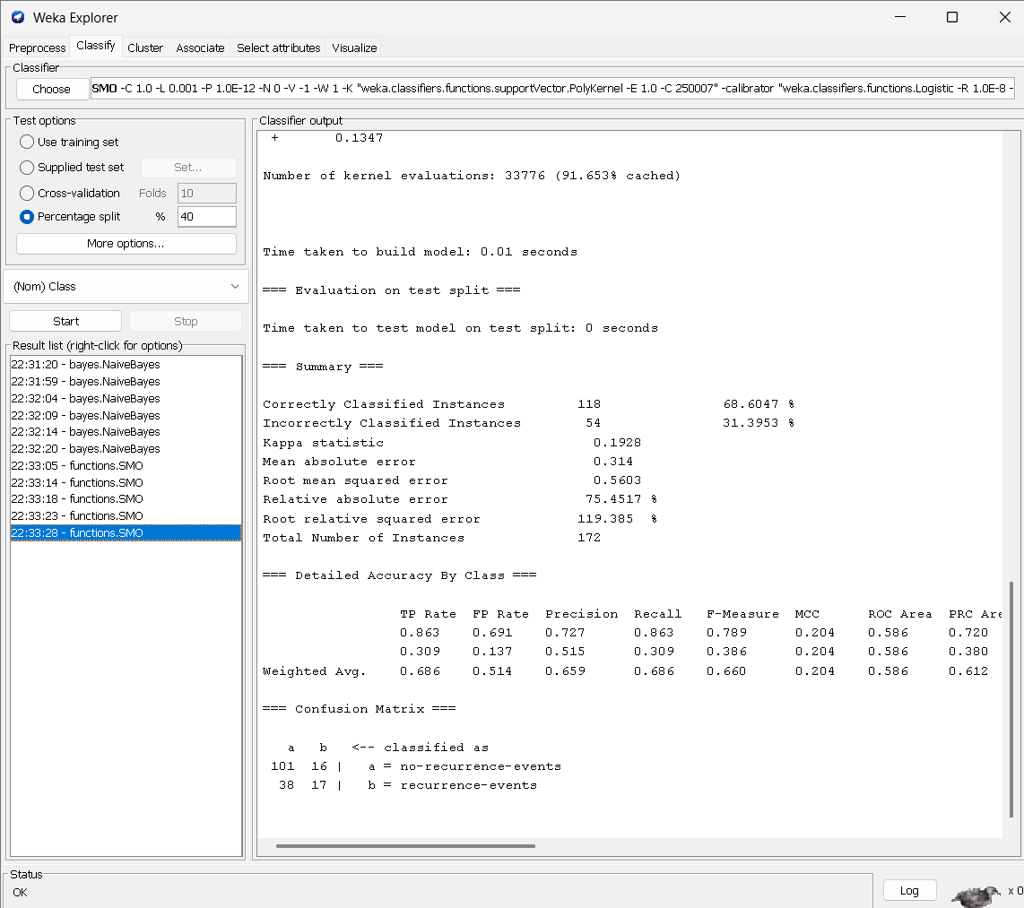

OUTPUT
- Classification accuracy
- Confusion matrix
- Precision, Recall, F-measure
- Error rate
- ROC area (for SVM)

RESULT
The Naïve Bayes and Support Vector Machine classifiers were successfully implemented using WEKA.
It was observed that:
- Naïve Bayes produced faster results with reasonable accuracy.
- SVM (SMO) achieved higher classification accuracy with lower error rate.
Thus, SVM performs better for complex datasets, while Naïve Bayes is efficient for quick predictions.

